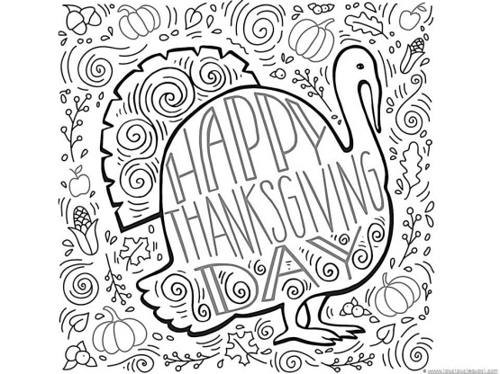

**Official Coloring Contest Rules**

**Eligibility** Panhandle children ages 5 - 15 may participate.

**Contest Period *Entries are due BY NOON on November 13th*** to be prize-eligible.

**To Enter: Color, complete and sign this release, and submit!**

**Submit entries to one of these locations:**

* **BBBS office 2nd floor of the Ragsdale Building.**
* **U.S. Mail:** BBBS of the TX Panhandle, PO Box 365, Perryton TX 79070
* **Frank Phillips College Front Desk**

Artists may use whatever coloring supplies they wish, including crayons, markers, colored pencils, etc.

Big Brothers Big Sisters cannot be responsible for late, lost or damaged entries.

**Ownership of Entries**

All entries become the property of Big Brothers Big Sisters upon submission. Entry materials will not be returned to any entrant.

**Prizes:**

Grand Prize includes a $20 United gift card!

One grand prize will be awarded for Ages 5-9

One grand prize for ages 10-15

Prize winners will be notified on November 15th via Contact number provided below and on the BBBS Facebook page. Winning artist's first name and age will be shared publicly. All prizes will be awarded with the winner’s parent/legal guardians present. Each prize winner as well as their parent/legal guardian’s consent to the use of the child’s first name, age, likeness (as a photograph) and prize information for promotional purposes without further payment.

**Release**

By entering the contest, winners and their parents or legal guardians release and agree to hold harmless Big Brothers Big Sisters, and each of their partners or employees, from any liability whatsoever in connection with this coloring contest.

Entrants agree to be bound by these official rules.

Child’s Name: _____________________________

Age: ____________________

Contact Number: __________________________

**__________________________________________**

***Parent/Guardian Signature***